Wed. March 1st 2023
The wind that shakes the Barley, Ken Loach, 2006
“Red line” for this semester is the “ land issue” in the British Empire and the Commonwealth.

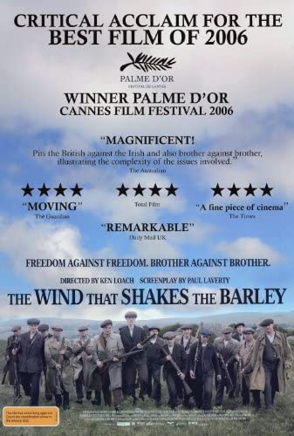
The action takes place during the Irish War independence ( 1919-1921) and the Irish Civil war (1922-1923) . Focus on Irish Republicans – the film won the Cannes film festival ‘s Palme d’Or
Ken Loach is interested in social issues in GB ( unemployment, homelessness ..) , “everyday realities of the British working class” : working class families/ denounces bureaucracy : ladybird ladybird (1994) + I Daniel Blake ( 2016 ) etc. Also well known for his sense of humour : See The Angel’s Share ( La part des anges ), 2012 https://www.britannica.com/biography/Ken-Loach

See 2 critics .
https://www.historyireland.com/film-eye-the-wind-that-shakes-the-barley/
https://www.theguardian.com/culture/2006/jun/23/3

→ 4 Aspects . Choose only 1 ( teamwork)
▪ 1. SONG/ BALLAD :” The wind that skakes the barley” is an Irish ballad. In your opinion, why has Ken Loach chosen this ballad as the title of his film?
https://www.youtube.com/watch?v=Y6wqbrPX-lA See if additional time Irish music and diasporic Irish ( Diaspora: migration of a group. Ex: dispersal of Jews from Palestine) https://academic.oup.com/edited-volume/35083/chapter-abstract/299101707?redirectedFrom=fulltext

▪ 2. HISTORICAL BACKGROUND / TIMELINE: Imagine an MCQ ( 8 questions) mainly using the elements I copied below. Send it to me : eeppcrouanveron@gmail.com
Also use https://en.wikipedia.org/wiki/Ireland
https://www.britannica.com/topic/Irish-Republican-Army
History:
Ireland was conquered by England in the 16th and early 17th (Tudor conquest) and ruled as a dependency until 1801 ( In 1801 The Acts of Union merged the kingdom of Ireland and the kingdom of Great Britain to create a United Kingdom of Great Britain and Ireland. ) See : The 1798 Rebellion in Ireland / Michael Colins , supporter of the 1921 treaty that led to the partition of the island.

It became a Republic in 1922 ( see role of the IRA) and was a member of the Commonwealth until 1949. “The Troubles” or “the Northern Ireland conflict” opposed the Protestant unionists ( lotyalists) who wanted to remain in the UK to the Roman Catholic nationalists ( republicans) who wanted Northern Ireland to be part of the Republic of Ireland lasted for about 30 years ( 1960s 1998) ( see Good Friday Agreement in 1998 ). In 1973, The Republic of Ireland joined the European Economic Community. In 2020 , Northern Ireland and the United Kingdom left the EU ( Brexit)
Politics:
Leo Varadkar, Irish Prime minister (centre-right) was reelected for the 2nd time in Dec. 2022. . His party , Fine Gael: Liberal conservative party ) and Fiana Fail ( centrist party/ has a partnership with the nationalist SDLP in Northern Ireland ). Opposed to Sinn Fein , (Nationalist Party , historic links with IRA ) Leader : Gerry Adams now retired . replaced by Mary Lou McDonald , Labour Party
Now: Coalition : Fianna Fàil Party ( with Michael Martin) + Fine Gael ( with Leo Varadkar) + Green Party (with Eamon Ryan)

Religion :
There are 2 main religious groups in Ireland . The majority of Irish are Roman Catholic while there is a smaller number of Protestant . ( 42,3% of the pop. identify as Catholic and 37,3% as Protestant or other Christian). See : https://theconversation.com/northern-ireland-census-shows-more-catholics-than-protestants-a-political-scientist-on-what-this-really-means-191273

Geography:
Ireland is the second –largest island in the British Isles and the third largest island in Europe.

My focus ( later) : See Ireland and Brexit , The Republic of Ireland has been a member state of The European Economic Community since 1973 ( Wed. 1 March 2023)

▪ 3. REPRESENTATION OF IRELAND: Give 8 Keywords and justify each word.
The island is divided into The Republic of Ireland ( 26 counties) and Northern Ireland ( The province of Ulster: 6 counties). Gaelic name Eire. : Etymology of the country’s name : Eire Land ( or Erin Land ) . Over time the name has morphed to Ireland.
See tourism: folklore, food, places to visit, famous people ( literary men and women, singers etc.)
Use : https://en.wikipedia.org/wiki/Ireland
and https://www.irishtourism.com/festivals

▪ 4. THE LAND FACTOR, Word bank : From what you know about the subject ( the history of the British Empire + the development of the Commonwealth + French, British … history etc.) can you make a list of important words dealing with the importance of land in the history of empires and in today’s geopolitical issues. The example of Ireland is a good starting point !
See also: https://en.wikipedia.org/wiki/Ireland
And https://academic.oup.com/edited-volume/35083/chapter-abstract/299101707?redirectedFrom=fulltext

Wordbank: Sovereign state , exile , identity, a dominion, a constituent country ( ex: Northern Ireland is a constituent country of the United Kingdom), settlers, etc…

