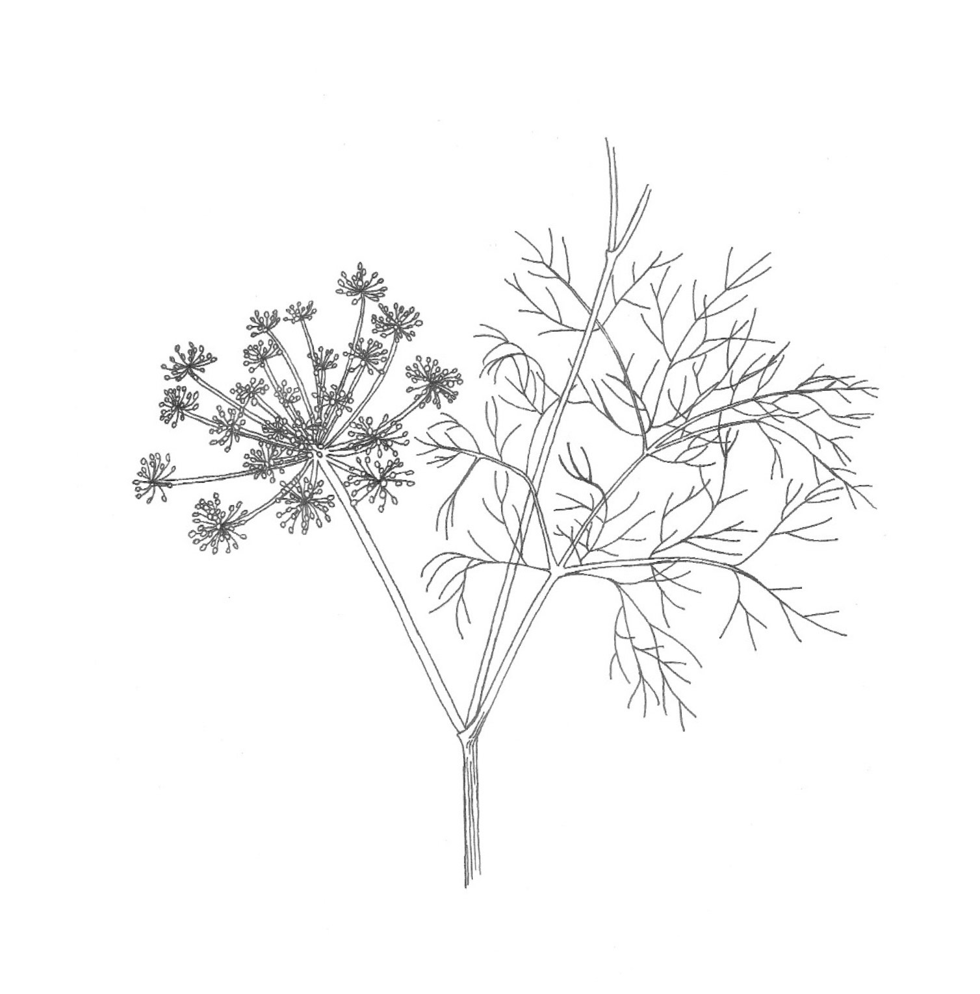
Funcho (Foeniculum vulgare)

