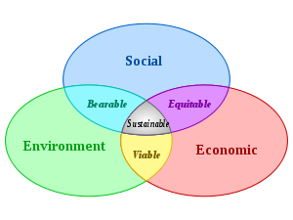

Sustainable development is about quality growth and economic development. It’s a pattern of resource use that aims to meet human needs while preserving the environment so that these needs can be met not only in the present, but also for future generations; Sustainable development must be each and everyone’s concern. So How to make development sustainable ?

To make development sustainable, First, we should spread awareness, Preserve natural resources and protect the environment. Second we have to encourage the use of renewable energy, Establish social and gender equality, Respect and defend human rights, Educate people and Empower women and youth. Third, governments should make efforts to eradicate poverty and hunger, improve peoples’ health , combat diseases by increase investments in health, education, infrastructure and environment. Furthermore, people should develop local and global partnerships for development, Promote self-employment. And this can only be achieved through true governance and total commitment of states and citizens.

